**International Club Weekend Retreat**

The International Club (IC) in Foulum invites you on a Weekend Retreat to [Thy](http://www.visitthy.dk/danmark/thy-turistbureau) in the company of your colleagues from **9 – 11 September, 2016**

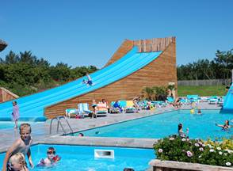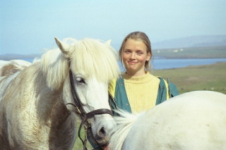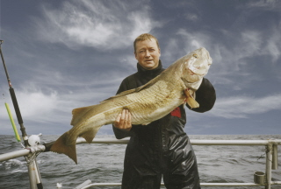

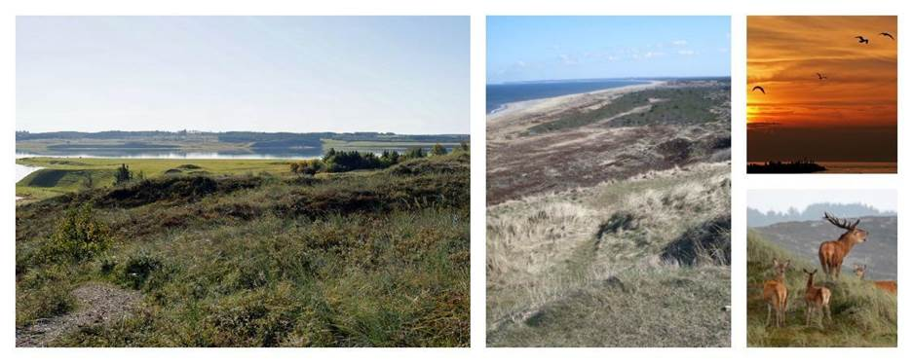

How about spending a weekend in the company of your colleagues from Foulum in the middle of the very unique nature that characterises Thy’s grand coastal landscape with direct access to the North Sea. Here, you will find the last wilderness in Denmark, and you can enjoy nature, relax at the beach, go fishing, go swimming, horse riding, cycle, visit popular places/events, etc.

Read more about Thy [here](http://www.visitthy.dk/danmark/thy-turistbureau)

Find below the programme for the weekend:

## ***Friday, 9 September***

3:00 pm                Leave from Foulum

5.00 pm                Arrive in Thy, drive to [Hanstholm camping site](http://www.hanstholm-camping.dk/uk.htm) where we will stay for two nights

## ***Saturday, 10 September***

Breakfast

Visit to an organic [sheep farm and shop](http://www.thylam.dk/)

Explore the [national park](http://eng.nationalparkthy.dk/) and the northwestern coast of Denmark

Choice of excursions on your own or with others from our group*

*Possible excursions:

•        Nature walks

•        Cycling

•        Swimming/beach

•        Horseback riding

Dinner

Entertainment

## ***Sunday, 11 September***

Breakfast, tidy up the cabins

Trip to [Fur Museum](http://furmuseum.dk/)

Lunch

3:30 pm                Depart from Fur

5.00 pm                Arrive in Foulum

*The International Club Weekend Retreat Committee will assist you to find an excursion if you need help.*

**Please register for the trip at the latest 4 July 2016**

**by e-mail to Emmanuel Arthur,** [**Emmanuel.Arthur@agro.au.dk**](mailto:Emmanuel.Arthur@agro.au.dk)

Please note that there are a limited number of places available, so it’s completely on a first-come-first-serve basis. Registration is accepted only after you have paid.

Please also note that the registration is **binding** except for emergencies such as sickness**.**

Please state the following in your email registration:

- *Name(s) of participants and ages of children if any*

*- Member of Staff Club:* **yes/no**

*- Driving license (for Denmark) and availability as a driver:* **yes/no**

*- Willing to drive others in your private car (if applicable):* **yes/no.** If yes, please indicate how many available seats

Please write **“Weekend retreat”** in the “Subject”

**Participation fee:**

Members of the Staff Club: 350 kr. per person.

Non-members of the Staff Club: 550 kr. per person

The price covers meals, lodging, and transportation from Foulum/Viborg.

**Payment** (after you have received email confirmation that there is room on the trip for you) to

*Bank No: 6610*

*Account no: 2757786*

Family members are welcome (full price). Children below 14 years are free.

Please note that for insurance reasons family members not employed by Aarhus University cannot travel in company cars. Those wishing to bring people not employed by AU should make their own travel arrangements. Those with cars who will be willing to drive other participants to the retreat are encouraged to state that in the registration so that we can allocate those who cannot drive in the Faculty cars. Private drivers get a fuel refund if they transport others.

Kindly forward any questions about the trip to Emmanuel Arthur [emmanuel.arthur@agro.au.dk](mailto:emmanuel.arthur@agro.au.dk), Jesper Overgård Lehmann [jespero.lehmann@agro.au.dk](mailto:jespero.lehmann@agro.au.dk);  Ejner Serup [ejner.serup@dca.au.dk](mailto:ejner.serup@dca.au.dk); Marcos Paradelo Pérez [marcos.paradelo@agro.au.dk](mailto:marcos.paradelo@agro.au.dk); Nina Høj Christiansen [nina.hoej.christiansen@agro.au.dk](mailto:nina.hoej.christiansen@agro.au.dk), Peter Obour Bilson [peter.bilson.obour@agro.au.dk](mailto:peter.bilson.obour@agro.au.dk); Alastair James Ward [alastair.ward@eng.au.dk](mailto:alastair.ward@eng.au.dk) .



Kind regards

Kind regards

Kind regards

|  |  |
| --- | --- |
| **Emmanuel Arthur** Researcher | **Dept. of Agroecology** Aarhus University Blichers Allé 20, Postboks 50 DK-8830 Tjele |
| Tel.: +45 87157635 Email: [emmanuel.arthur@agro.au.dk](mailto:emmanuel.arthur@agro.au.dk) | Tel: +45 871 56000  Web: <agro.au.dk> |

